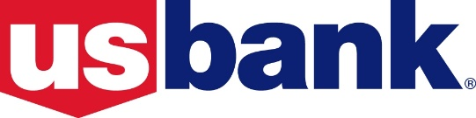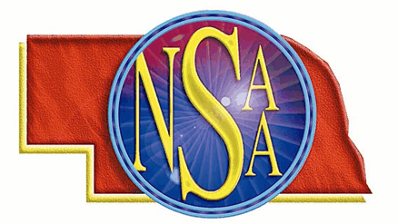

As an Outstanding Student,

The Nebraska School Activities Association and

U.S. Bank would like to recognize

(Insert Name Here)

(Insert School Name Here) High School

BELIEVERS

&

ACHIEVERS

SCHOLASTICS – ACTIVITIES – CITIZENSHIP – INVOLVEMENT

School Winner

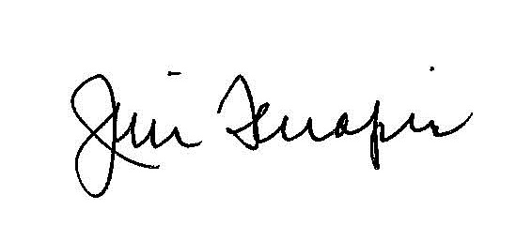

NSAA Executive Director